VIMEO TO EXCLUSIVELY PREMIERE A SPIKE LEE JOINT “DA SWEET BLOOD OF JESUS” ONE MONTH BEFORE THEATRICAL RELEASE
Available Today, January 13th, Across North America on Vimeo On Demand

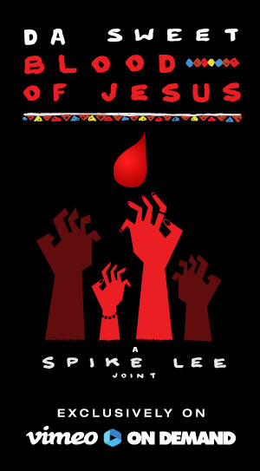

New York (January 13, 2015) – Vimeo and Spike Lee announced today that the newest Spike Lee Joint, “Da Sweet Blood Of Jesus,” will be released exclusively on Vimeo On Demand one full month before it hits theatres. The film is available today for purchase and rental on Vimeo On Demand (vimeo.com/ondemand/dasweetbloodofjesus) and can be viewed on any connected device.

“I’m hyped on my partnership with Vimeo to get my new joint ‘Da Sweet Blood of Jesus’ out to the world in a new way,” said Spike Lee. “This is the future of film distribution. Please join us.”

“Spike Lee is one of the most iconic filmmakers of our time and we couldn’t be more thrilled to work with him on this unprecedented release,” said Greg Clayman, General Manager Audience Networks, Vimeo. “We are huge fans of Spike and were drawn to the film’s independent spirit. Having built an audience and raised over a million dollars on Kickstarter, we are beyond excited to bring the film to fans directly one month ahead of the theatrical release.”

A Spike Lee Joint, “Da Sweet Blood of Jesus” is a new kind of love story, one that centers on an addiction to blood that once doomed a long forgotten ancient African tribe. When Dr. Hess Green (Stephen Tyrone Williams) is introduced to a mysteriously cursed artifact by an art curator, Lafayette Hightower (Elvis Nolasco), he is uncontrollably drawn into a newfound thirst for blood that overwhelms his soul. He, however, is not a vampire. Lafayette quickly succumbs to the ravenous nature of the infliction but leaves Hess a transformed man. Soon Lafayette’s wife, Ganja Hightower (Zaraah Abrahams), comes looking for her husband and becomes involved in a dangerous romance with Hess that questions the very nature of love, addiction, sex, and status in our seemingly sophisticated society. A reinterpretation of Bill Gunn’s horror cult film “Ganja & Hess”, which played as a Critics Choice at the 1973 Cannes Film Festival, Spike Lee’s stylized thriller features an Original Score by Bruce Hornsby.

The film is available in the U.S. for a $9.99 24-hour streaming rental or $14.99 digital download.

About Vimeo
Vimeo® is the high-quality video platform for creators and their audiences. Vimeo’s mission is to empower and inspire people around the world to create, share and discover videos. Vimeo has over 26M registered members and reaches a global monthly audience of more than 170M. Founded in 2004 and based in New York City, Vimeo, LLC is an operating business of IAC (NASDAQ: IACI).

MEDIA CONTACTS:
Jessica Casano-Antonellis | Jessica@vimeo.com | 212.524.7164
Kevin Turner | KevinT@vimeo.com |212.524.7123

